Dummy Load
I knew a dummy load would be a useful tool at any ham station. I didn't have one, so I did what hams have done from the beginning. I set out to build one.
A search of the internet turned up an article by Ken Kemski, K4EAA. His design looked simple and inexpensive enough, so I downloaded the parts list and ordered the components that I did not have in my junk box. While I waited for the parts to arrive, I went to the hardware store to get the few mechanical parts. Once the parts arrived, I was ready to build my dummy load.
I drew out a plan for the holes on paper, then center punched the pattern into the two pieces of brass. I drilled small holes for the leads and drilled the can lid for the BNC connector and for the binding posts.
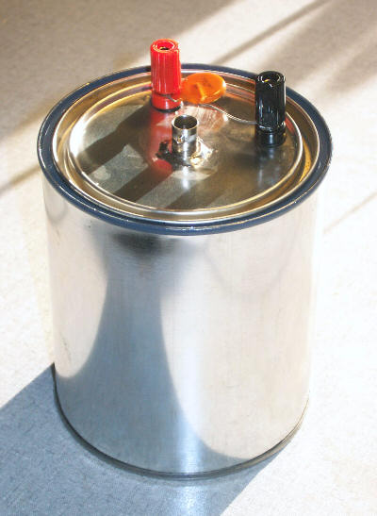
Following the instructions on the website article, I assembled the parts. I did have some difficulty sealing the connections through the lid. There was initially some leakage of the cooling mineral oil around the connectors. A little Flex Shot, you know, ‘As Seen on TV’ stuff, did the trick.
I added a .01 uF / 250V ceramic disk capacitor across the binding posts,. This enabled me to measure peak transmitter power using my DVM. The formula is related below.
I added a label to the can to remind me how to compute transmitter power out from the voltage measured at the binding posts.

((V + 0.4)/1.414)² / 50 = PEP Power
Example:
((99,6+0.4) / 1.414 )² / 50 = 70.72² / 50 = 5001 / 50 = 100.03

K9HOU - Robert Ewers

Footnotes:
plans and schematic - https://k4eaa.com/dummy.html
electronic components – https://www.mouser.com
mechanical components – https://www.acehardware.com

